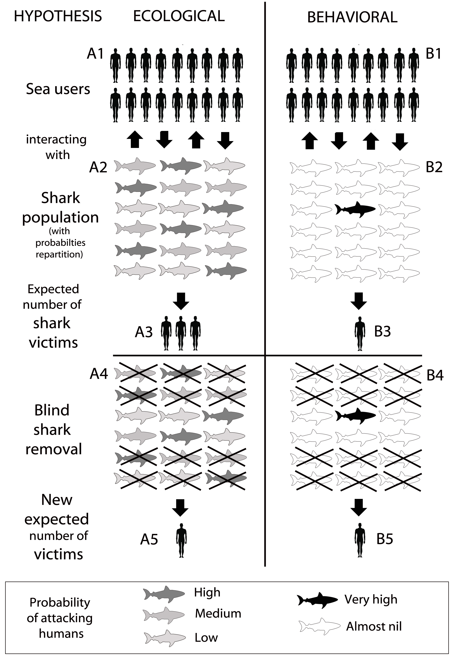
Legend – Schematic representation of the patterns of probabilities repartition among sharks to attack humans as it should work if the ‘ecological’ hypothesis was met (left) and how it probably works based on the ‘behavioral’ hypothesis (right). For a given population of sea users (A1=B1), there is interactions with a given shark population. Following the ‘ecological’ hypothesis (left), A2 would be composed of a certain amount of sharks, each of them hosting a variable probability (different from 0) of attacking humans (here equally shared on a 1-3 scale from high to low). Given the interactions and the probabilities repartition, lets choose the number of expected victims to be three (per year) (A3). If the risk was directly correlated to shark density, after culling 60% of the shark population (A4), the number of victim would decrease to one victim per year (A5). Following the ‘behavioral’ hypothesis (right), the probability of attacking humans is mainly concentrated into one ‘deviant’ shark while all conspecifics hold a probability close to 0 (as humans are not targetted by shark) (B2). Based on the shark-human interaction, the number of victims would be much lower (assumption of one per year) (B3). After culling 60% of that shark population, without including the ‘deviant’ shark (which is highly probable) (B4), the number of victim would remain unchanged (B5). Although oversimplified, the comparison of these patterns reveals that the ‘behavioral’ pattern (low and unchanged number of victims after culling) seems closer to the reality (see Weterbee et al. 1994) than the ‘ecological’ pattern (with higher attack rates that would be modified by shark culling) that is not supported by any studies or analysis.

